V. Charishma
2520030140
Section:8
Skill 3: Command History and Dynamic Memory Management
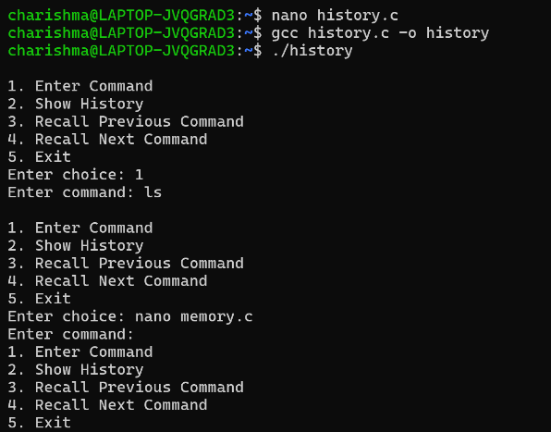
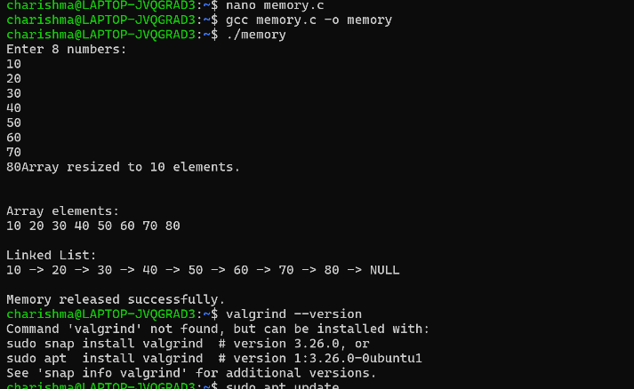
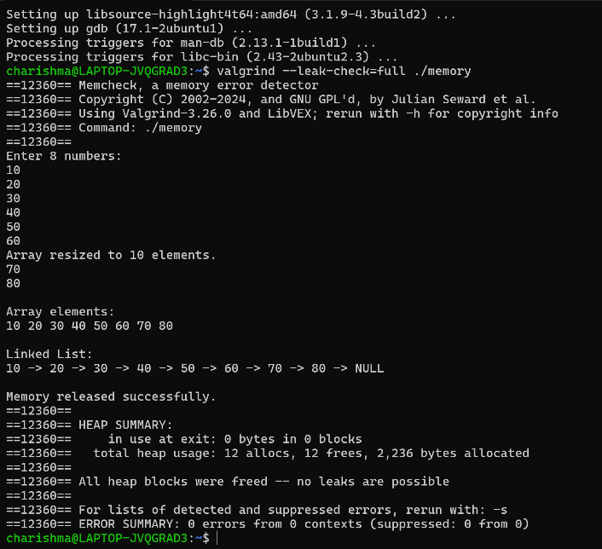
Result:
The program was successfully executed and memory was properly managed without leaks.

